**Small Project**

**Accident Prevention Program**

Safety plan for small and mobile job sites.

# Read Before Proceeding

All employers in Washington State are **required** to have a site specific written **Accident Prevention Program** (APP) that is effective in practice [***WAC 296-800-140***](http://www.lni.wa.gov/safety/rules/chapter/800/WAC296-800.PDF#WAC_296_800_140) **IT’S THE LAW!**

Businesses that have effective accident prevention programs not only can prevent costly citations from DOSH safety inspectors, they are more likely to sustain their company workers compensation performance which can result in lower experience modification ratings, lower workers compensation costs, higher employee morale and retro refunds.

Writing an APP is not difficult and with a little time and effort you will have a program that will save you money, prevent injuries and put you in compliance with regulations.

Every jobsite has its own special hazards therefore your APP needs to be site specific to your jobsite. **GRIP encourages you to copy, modify and expand upon this template to create your own site-specific safety program.**

To meet the basic APP requirements, businesses need to do the following:

* Identify site specific hazards that could harm employees.
* Develop ways to mitigate, eliminate and communicate hazards to team.
* Develop written accident prevention program that is site specific.
* Provide a detailed safety orientation for new employees and document.
* Deliver weekly toolbox safety talks that are documented.
* Conduct weekly jobsite safety inspections that are documented.

If you need additional assistance in setting up your written Safety Program please feel free to contact your ERNWest Safety and Loss Control Representative for additional information – charges may apply.

Workplace safety is vital to keeping a workforce healthy. The key to keeping costs at a reasonable level in Washington State is to prevent injuries from occurring in the first place. By implementing the recommendations we have outlined, we are not guaranteeing that injuries will not occur, but we believe that with these items in place, they will give you a better chance at preventing costly claims. ***Our loss prevention service is advisory only and we assume no responsibility for management or control of customer safety activities nor for implementation of recommended corrective measures.*** This report is based on information supplied by the client and/or observations of conditions and practices at the time of the visit. We have not tried to identify all hazards. We do not warrant that requirements of any federal, state or local law, regulation or ordinance have or have not been met.

# Responsibilities

**\*\*Note: Modify language below to reflect your company’s expected responsibilities**

1. **Management**

Active participation in and support of safety and health programs is essential. Management officials will display their interest in safety and health matters at every opportunity. At least one manager (as designated) will participate in the safety meetings, incident investigations and inspections. Each manager will establish realistic goals for implementing instructions for meeting the goals.

1. **Supervisors**

The safety and health of **(Company Name Here)** employees is a primary responsibility of the supervisors. To accomplish this obligation, supervisors will:

|  |  |
| --- | --- |
| 1. | Assure that all safety and health rules, regulations, policies and procedures are understood and being followed. |
| 2. | Require the proper care and use of all required personal protective equipment. |
| 3. | Identify and eliminate job hazards quickly through job hazard analysis procedures. |
| 4. | Inform and train employees on the hazardous chemicals and/or procedures they MAY encounter under normal working conditions or during an emergency situation. |
| 5. | Receive and take initial action on employee suggestions, awards or disciplinary measures. |
| 6. | Conduct crew/leader meetings at least weekly to discuss safety and health matters, job hazard analysis, and work plans for the workday. |
| 7. | Conduct walk-around safety inspections at the beginning of each job, and at least weekly thereafter. |
| 8. | Train employees (new and experienced) in the safe and efficient methods of accomplishing each job or task as necessary. |
| 9. | Participate in incident investigations by completing **incident report form and submitting form to ERNwest.** |
| 10. | Promote employee participation in the safety and health program. |
| 11. | Actively follow the progress of injured workers and display an interest in their rapid recovery and return to work. |
|  |  |

###### **Employees**

Observe the items of responsibility established in this document as well as job safety rules which may apply to specific task assignments.

1. Will actively participate by identifying and reporting workplace hazards.
2. Follow all company safety and health rules including PPE requirements.
3. Notify supervisor of all workplace injuries.
4. Engage and participate in safety meetings and trainings provided by **(Company Name Here)**

# General Safety Rules

**\*\*Note: Customize rules to meet specific jobsite hazards. Print off and use as part of your new hire safety orientation training.**

1. Always store materials in a safe manner to prevent falling, rolling, or shifting.
2. Shavings, dust scraps, oil or grease should not be allowed to accumulate.
3. Trash piles must be removed as soon as possible. Trash is a safety and fire hazard.
4. Remove or bend nails in lumber that has been used or removed from a structure.
5. Immediately remove all loose materials from stairs, walkways, ramps, platforms, etc.
6. Do not block aisles, traffic lanes, fire exits, gangways, or stairs.
7. Guardrails must be erected around floor openings and excavations must be barricaded.
8. Do not remove, deface or destroy any warning, danger sign, or barricade.
9. Get help with heavy or bulky materials to avoid injury to yourself or damage to material.
10. Keep all tools away from the edges of scaffolding, platforms, shaft openings, etc.
11. Do not use tools with split, broken, or loose handles, or burred or mushroomed heads.
12. Know the correct use of hand and power tools. Use the right tool for the job.
13. Know the location and use of fire extinguishing equipment.
14. Proper guards or shields must be installed on all power tools before use. Do not use any tools without the guards in their proper working condition.
15. All electrical power tools, extension cords, and equipment must be properly grounded.
16. All electrical power tools and extension cords must be properly insulated. Damaged cords must be replaced.
17. All electrical power equipment and tools must be grounded or double insulated.

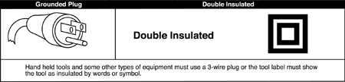

1. Inspect all ladders and now how to properly set up ladders before using.

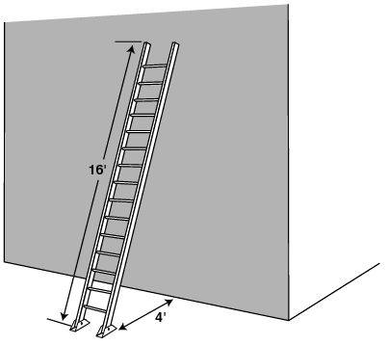 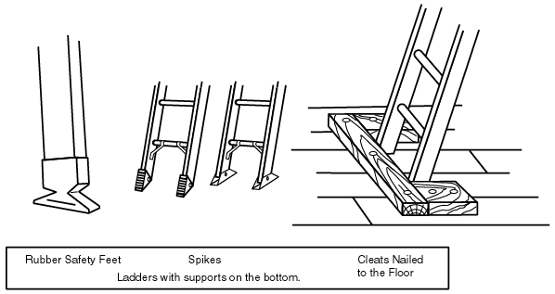 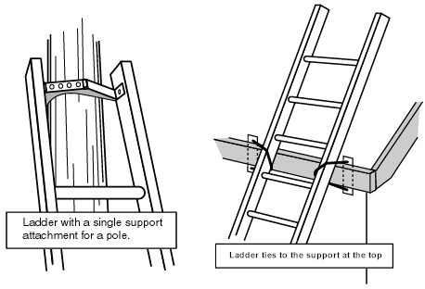

**Sample Site Specific Emergency Plan**

**(For this job site: Post on bulletin board and/or on front of Safety Manual)**

Worksite Address: __________________________

Phone Number: ___________________________

Worksite Supervisor: _____________ Phone: _______

Fire / Emergency Call: ______________________

Nearest Hospital/ Occupational Medical Clinic:

|  |  |  |
| --- | --- | --- |
| Name | Address | Phone |
|  |  |  |

First Aid Certified Employees:

|  |  |
| --- | --- |
| Name | Card Expiration Date |
|  |  |
|  |  |

First aid kit location(s):

|  |
| --- |
|  |
|  |

Assembly point after evacuation:

|  |
| --- |
|  |

Other emergency information:

|  |
| --- |
|  |

|  |  |  |  |  |  |  |
| --- | --- | --- | --- | --- | --- | --- |
| Job Hazard Analysis Worksheet | | | | | | |
| **CONTRACTOR:** |  | | | **WORK START DATE:** | |  |
| **BLDG/ LOCATION:** |  | | | **EST. WORK COMPLETION DATE:** | |  |
| **EMERGENCY CONTACT** |  | | | | | |
| **TRADES INVOLVED:** |  | | | | | |
| **SCOPE OF ACTIVITY – LIST BASIC JOB STEPS:** |  | | | | | |
| **\*REMINDER:** Review Safety Data Sheets and incorporate appropriate preventative or protective measures. | | | | | | |
| ***CHECK THE BOX ASSOCIATED WITH EACH POTENTIAL HAZARD*** | | | | | | |
| Slips/Trips/Falls | | Chemical Spill | | | Poor Lighting | |
| Electrical Shock/Arc Flash | | Heavy Equipment | | | Noise Exposure | |
| Elevated Work | | Welding/Hot Work/Grinding | | | Dust/Inhalation Exposure | |
| Falling Objects | | Struck-by/Caught-in/Between | | | Poor Ventilation | |
| Manual Lifting | | Flammable Materials | | | Impact to Connected Systems  (such as Sprinkler, Fire, alarms,  other Controls/Processes) | |
| Excavation Cave-in | | Cold/Heat Exhaustion/Stress | | |
| Thermal/ Chemical Exposure | | Poor Work Position | | |
| Fire/Explosion | | Radiation | | | Other (describe): | |
| Confined Space | | Stored Energy | | |
| ***LIST THE POTENTIAL HAZARD AND SAFETY MEASURES FOR EACH STEP*** | | | | | | |
| **HAZARD** | | **MEASURES TAKEN TO ENSURE SAFETY** | | | | |
|  | |  | | | | |
|  | |  | | | | |
|  | |  | | | | |
| ***PLACE A CHECKMARK NEXT TO ALL THAT APPLY*** | | | | | | |
| **PERSONAL PROTECTIVE EQUIP'T** | | **WORK PLATFORMS FOR TASK** | | | **ENERGIZED EQUIPMENT/SYSTEMS** | |
| FULL FACE SHIELD/SAFETY GLASSES | | SCAFFOLD w/ STD. GUARDRAILS | | | GROUND FAULT PROTECTION | |
| CHEMICAL SPLASH GOGGLES | | PERSONNEL LIFT (Worker Trained) | | | LOCK-OUT/TAGOUT | |
| RESPIRATORY PROTECTION | | LADDERS (Fiberglass or Wood) | | | ENERGY SOURCES IDENTIFIED | |
| HARNESS/ LANYARD/ ANCHORAGE | | **MATERIAL HANDLING** | | | TOOLS/CORDS INSPECTED  & RATED for APPLICATION | |
| POSITIONING DEVICE | | RIGGING EQPT. INSPECTED/TESTED | | | HIGH VOLTAGE LINES IDENTIFIED | |
| GLOVES (specify): | | CRANE | (Size):  (Type): | | AREA CONTROLS/ISOLATION DETERMINED | |
| WELDING HOOD | | OPERATOR CERT. | | | **FIRE PROTECTION** | |
| PROTECTIVE HEADWEAR | | ASSEMBLY/DISASSEMBLY DIRECTOR | | | FLAMMABLES REMOVED | |
| FLAME RESISTANT CLOTHS | | **CONFINED SPACE** | | | WELDING SCREEN IN PLACE | |
| OTHER PPE (specify): | | EMPLOYEES TRAINED | | | SPKLR. IMPAIRED/DRAINED | |
| **BARRICADES NEEDED** | | AIR TESTED/MONITORED | | | FIRE WATCH ASSIGNED | |
| COVERS on FLOOR HOLES | | **OTHER (List):** | | | SUITABLE FIRE EXTINGUISHER | |
| VISUAL BARRICADES/SIGNS | |  | | | AREA FREE of DEBRIS | |
| **Tasks Requiring a Permit**: | | | | | | |
| Welding/Burning  Confined Space  Roof Entry  Excavation/Trenching  Refrigerant Recovery  LO/TO  Line Breaking   Wall Penetration/Cabling  Sprinkler/Fire Impairment  Other (specify below): | | | | | | |

# Unified Fall Protection Quick Reference Guide *New Guidelines as of October 2020*

WAC 296-880

| **GENERAL FALL PROTECTION FOR ALL INDUSTRIES** | **THRESHOLD HEIGHT** |
| --- | --- |
| Above or adjacent to dangerous equipment | Regardless of height |
| Holes into which an employee can trip, step into, or step through | Regardless of height |
| Falling into or onto impalement hazards | Regardless of height |
| When on a walking/working surface | Four feet or more |
| Ramps, runways, and inclined walkways | Four feet or more |
| Holes where work is being performed | Four feet or more |
| Skylights | Four feet or more |
| Hatchway and chute openings | Four feet or more |
| Ladderways | Four feet or more |
| Pits and trap door holes | Four feet or more |
| Repair pits and service pits | Four feet or more |
| Manholes | Four feet or more |
| Openings | Four feet or more |
| Formwork and reinforcing work | Four feet or more |
| Steep pitch roof – regardless of task | Four feet or more |
| Low pitch roofs – other than roofing work or constructing a leading edge | Four feet or more |
| Hazardous slopes | Four feet or more |
| Vehicles and rolling stock – if unable to provide fall protection or creates a greater hazard | Four feet or more |
| **Construction work *\*See also Chapter 155 WAC*** | |
| Roofing work on a low pitch roof | Six feet |
| Constructing a leading edge | Six feet |
| Engaged in the erection or placement of structural members | Ten feet |
| Engaged in excavation and trenching operations | Ten feet |
| **Elevating work platforms *\*See also Chapter 869 WAC*** | |
| Vehicle mounted aerial devices | Regardless of height |
| Manually propelled and self-propelled elevating work platforms | Regardless of height if required by manufacturer |
| Boom supported elevating work platforms | Regardless of height |
| **Powered Platforms *\*See also Chapter 870 WAC*** | |
| Working on a roof or other elevated working area | Four feet or more |
| **Window Cleaning *\*See also Chapter 878 WAC*** | |
| Working on a roof or other elevated working area | Four feet or more |
| General fall protection for all industries | Threshold height |
| **Scaffolds *\*See also Chapter 874 WAC*** | |
| Working on a scaffold | Ten feet or more |
| **Cranes – *Under the scope of Chapter 155 Part L*** | |
| For nonassembly/disassembly work | Six feet or more |
| For assembly/disassembly work | Ten feet or more |
| Towercranes – Work other than erecting, climbing, and dismantling | Six feet or more |
| Towercranes – erecting, climbing, and dismantling work | Ten feet or more |
| Telecommunications work *\*See also Chapter 32 WAC* | Four feet or more |
| Qualified electrical workers *\*See also Chapter 45 WAC* | Four feet or more |
| **Ship Repairing, Shipbuilding and Shipbreaking *\*See also Chapter 304*** | |
| Working aloft or elsewhere at elevation | Five feet or more |
| **Longshore, Stevedore and Waterfront Related Operations *\*See also Chapter 56 WAC*** | |
| Maintenance work on cranes, spouts or similar types of equipment | Eight feet or more |
| Floor or wall openings or waterside edges, including bridges or gangway-like structures | Four feet or more |
| *Click* [*here*](http://www.lni.wa.gov) *for more information on the Unified Fall Protection Rule* | |

# Unified Fall Protection Work Plan – Sample

***WAC 296-880-10020 Unified Fall Protection***: You must develop and implement a written fall protection work plan including each area of the workplace where the employees are assigned and where fall hazards of 10ft or more exist. The plan must be made available on the job site for L&I compliance inspections.

**Company Name: ____________________________________**

**Site Address: _______________________________________**

**Emergency Contact: ___________________ Phone: _______________**

**Identify all Fall Hazards of 10ft or more**

|  |  |  |  |  |  |
| --- | --- | --- | --- | --- | --- |
| Check the fall hazard/s box below that represent onsite fall hazards 10ft or more above ground on your project.  Write a brief description of hazard using the hazard box below. | | | | | |
| EXAMPLE:  Skylights | X | Fall hazard of 10ft on north end of project. No railings currently erected. | | | |
| **Open-sided floors** |  |  | **Stairwell** |  |  |
| **Leading**  **edge work** |  |  | **Window**  **Opening** |  |  |
| **Decks/Balconies** |  |  | **Roofs** |  |  |
| **Holes** |  |  | **Mobile lift work** |  |  |

**Other Fall Hazards in Area**

# Method/s of Fall Protection

|  |  |  |  |  |  |
| --- | --- | --- | --- | --- | --- |
| Check box for the fall protection method/s being used for the identified fall hazards identified above.  (LSO=Low Slopes Only. Low Slope = 4 X 12 or less) | | | | | |
| **Personal Fall Arrest System** |  |  | **Positioning Device** |  |  |
| **Fall Restraint System** |  |  | **Covers** |  |  |
| **Horizontal**  **lifeline** | See the source image |  | **Vertical lifelines & Rope grab** |  | See the source image |
| **Guardrail system (LSO)** |  |  | **Safety net** |  |  |
| **Warning line with safety monitor (LSO)** |  |  | **Safety Watch System (LSO)** |  |  |

|  |  |  |
| --- | --- | --- |
| Additional Instructions: | | |
|  | | |
| Describe procedures for assembly, maintenance, inspection, and disassembly of fall protection system to be used below. | | |
|  | | |
| Describe procedures for handling, storing and securing tools, equipment and materials. | | |
|  | | |
| Describe methods of overhead protection for workers who pass-through work areas. | | |
|  | | |
| Describe methods for prompt rescue of employees in the event of a fall. | | |
|  | | |
| Employees who received fall protection training on the above site-specific work plan. *(List full names)* | | |
|  |  |  |
|  |  |  |
|  |  |  |
|  |  |  |
| Employer/employer’s designee signature verifies that employees are trained and instructed on plan: | | |
|  |  |  |
| Name | Title | Date |

# Global Harmonization System

**(Company Name Here)**is committed to the prevention of exposures that result in injury and/or illness; and to comply with all [**WAC 296-901 Global Harmonization System (GHS) Rules**](http://www.lni.wa.gov/Safety/Topics/AtoZ/ghs/). To make sure that all affected employees know about information concerning the dangers of all hazardous chemicals used.

**Safety Data Sheets (SDS):**

**(Name Here)**is responsible to establish and monitor the SDS program. This person will make sure SDSs are obtained for all hazardous chemicals used in the workplace and review them for new or significant health and safety information changes. This person will see that any new information is passed on to affected employees. In addition, they will be responsible for updating the SDS book.

SDS books are always available to all employees for all hazardous chemicals in use and will be kept at main office computer drive. If an SDS is not available or a new chemical in use does not have an SDS, immediately contact the (**Name Here).**

**Employee Information and Training:**

**(Name Here)**is responsible for the employee training.

The procedures for how employees will be informed and trained are as follows:

* An overview of the requirements contained in the Global Harmonization Hazardous Chemicals Standard present in the work area.
* Physical and health risks of the hazardous chemical.
* The symptoms of overexposure.
* How to determine the presence or release of hazardous chemicals in the work area.
* How to reduce or prevent exposure to hazardous chemicals through use of control procedures, work practices, and personal protective equipment.
* How to read labels and review SDSs to obtain hazard information.
* Location of the SDS file and written GHS program.

Before introducing a new chemical hazard into any work area of this employer, each affected employee will be given an orientation as outlined above for the new chemical.

The following is a list of all known hazardous chemicals used by our employees.

*Note: List all hazardous chemicals below, attach list in excel or word document, you can also list the place where the list is located (ix. List of hazardous chemicals can be found in the jobshack office).

# Global Harmonization Labels

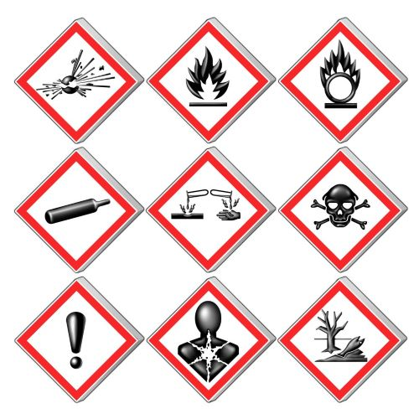

# Outdoor Heat Stress

Working outdoors in hot weather can result in serious illness or even death. Workers exposed to extreme heat may experience symptoms of heat-related illnesses (HRI), such as heat cramps, heat rash, heat exhaustion, fainting, heat stroke and other symptoms.

Heat-related illness is also linked to injuries from falls, equipment operation accidents and other on-the-job incidents. Such incidents can happen when someone with heat stress becomes fatigued, dizzy, confused, or disoriented.

Employers must address heat stress in their outdoor heat exposure safety program which includes, [safety training](https://wisha-training.lni.wa.gov/training/articulate/HeatIllness/story.html) on signs and symptoms of heat stress, providing water and shade and rest. The **Outdoor** Heat Exposure Rule [WAC 296-62-095](http://apps.leg.wa.gov/WAC/default.aspx?cite=296-62&full=true#296-62-095) **applies** from **May 1 through September 30,** every year, when exposures are **at or above a specific temperature**. Additional requirements must be met when outdoor temperatures meet or exceed 89 degrees Fahrenheit.

**Provide Water**

* **(Company Name Here)** will supply water and encourage employees who work in hot weather to drink regularly, even when not thirsty. Employees will have enough drinking water to drink at least 1 quart (four 8 ounce glasses) per hour.
* Ensure drinking water is suitably cool and readily accessible to workers at all times.

**Shade and Rest**

* When temperatures reach or exceed 89 degrees; **(COMPANY NAME HERE)** will ensure that employees take mandatory cool-down rest periods for at least 10-mins every 2-hrs and;
* Provide workers access to shade for preventative cool-down rest when needed.
* If the temperature is 100 degrees or higher, **(COMPANY NAME HERE)** will ensure there is enough cooling shade to accommodate all workers on a break.
* Shade must block direct sunlight and not be in areas where the heat defeats the purpose of the shade, such as in a car without running air conditioning.
* Both preventative cool-down rest time and mandatory preventative cool-down rest periods will be paid unless taken during a meal period.
* Alternative cooling methods may be used instead of shade, such as temperature- controlled environments like air-conditioned trailers or misting stations.

# Signs/Symptoms of Heat-Related Illness

* **(COMPANY NAME HERE)** will respond to workers showing signs and symptoms of heat-related illness by relieving them from duty, providing shade or other sufficient means to cool down, and monitoring to determine whether medical attention is necessary by:
  + Observing workers for alertness and signs or symptoms of heat-related illness,
  + Creating a buddy system when working alone in hot weather
  + Monitor workers through regular communication, such as radio or cellular,
  + including workers that are working alone or performing duties in areas where observation is not possible.
* Ensure effective procedures for obtaining emergency medical services when needed. Time is critical.

**Prevention**

* Inform workers they should avoid alcohol or drinks with caffeine prior to work in hot weather.
* Try to do the heaviest work during the cooler parts of the day.
* Allow workers time to acclimatize. Start slower and work up to your normal pace over time.
* Wear lightweight, loose-fitting, light-colored, breathable (e.g. cotton) clothing and a hat.

**Additional Resources**

[Heat Illness Prevention Campaign | Occupational Safety and Health Administration (osha.gov)](https://www.osha.gov/heat)

[Be Heat Smart (wa.gov)](https://lni.wa.gov/safety-health/safety-training-materials/workshops-events/beheatsmart)

[Heat - Heat Hazard Recognition | Occupational Safety and Health Administration (osha.gov)](https://www.osha.gov/heat-exposure/hazards)

[FY22-002 Hazard Alert: Extreme Heat Events (wa.gov)](https://lni.wa.gov/safety-health/preventing-injuries-illnesses/hazardalerts/Extreme-Heat-Events-Hazard-Alert.pdf)

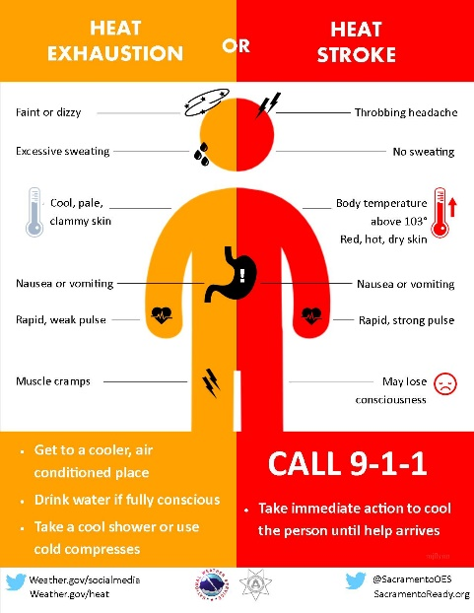

# Construction Self-Inspection Checklist

|  |  |
| --- | --- |
| **□** | **Power lines**: Minimum 10’ clearance / insulate – de-energize, under 50 kw; over 50 kw |
| **□** | **Trench/excavation**: Any trench four feet or must be sloped, shored or braced |
| **□** | **Guardrails**: Any opening four feet or more above ground level must be guarded |
| **□** | **Standard guardrail**: Top rail = 39” to 45” above working surface. Midrail = halfway between top rail and floor. Toeboard = 4”. |
| **□** | **Scaffold**: Fully planked |
| **□** | **Scaffold**: Fall protection provided if fall hazards over 10 feet exist |
| **□** | **Stairs**: Four or more risers must have handrails |
| **□** | **Fall protection**: Fall Protection MUST be implemented at 0 feet if there is the potential for serious injury or death. For example, working on a surface next to mechanical equipment that could fall into would need fall protection. 4ft for walking working surfaces and exposure to fall hazards of 10’ or greater must be eliminated by the use of safety harness/belt, lanyard or lifeline, horizontal lines, or cantenary lines. Positive fall restraint/protection must be utilized at all times. Two lanyards may be necessary at the beam/upright traverse points. No exposure at any time is allowed. |
| **□** | **Fall protection work plan**: Job specific, in writing; available on-site for all fall hazards above 10’. |
| **□** | **Radial saws**: Cutting head must return easily to start position when released; blade must not extend past the edge of the worktable; off/on switch should be at front of operator’s position. |
| **□** | **Circular saws**: Blade guard instantly returns to covering position |
| **□** | **Never wedge or pin a guard.** |
| **□** | **Ladders**: Extended 36” above landing and secured to prevent displacement |
| **□** | **Articulating boomlift**: Safety harness and lanyard at all times |
| **□** | **Floor holes/openings**: Covered and secured; be sure no tripping hazards in the area. |
| **□** | **Extension cords/electric power tools**: Marked/covered by Assured Grounding Program |
| **□** | **Clothing**: Minimum of short sleeve shirts, long pants, and substantial footwear; no recreational shoes |
| **□** | **Hard hats**: readily accessible at all times; worn when overhead hazard exists |
| **□** | **Personal protective equipment**: Head, eye, ear, respiratory, and leg protection – high visibility vests when required |
| **□** | **Housekeeping**: Workers are responsible for their own area of exposure |
| **□** | **First aid/fire extinguishers**: Available and readily accessible |
| **□** | **First aid trained personnel**: Minimum of one person on-site at all times with first aid CPR training. |
| **□** | **Accident Prevention Program**: In written format |
| **□** | **Crew Leader Meetings**: At beginning of each job and at least weekly thereafter. Documented |
| **□**  **□**  **□** | **Global Harmonization Program** with Safety Data Sheets for Hazardous Chemicals  **Job Hazard Analysis** completed for site specific job  **Injury Management Procedures** in place for workplace incidents |
|  |  |
|  | **\*\*Note: May need to add or delete bullets based on site specifics of the job.** |
|  |  |
|  |  |